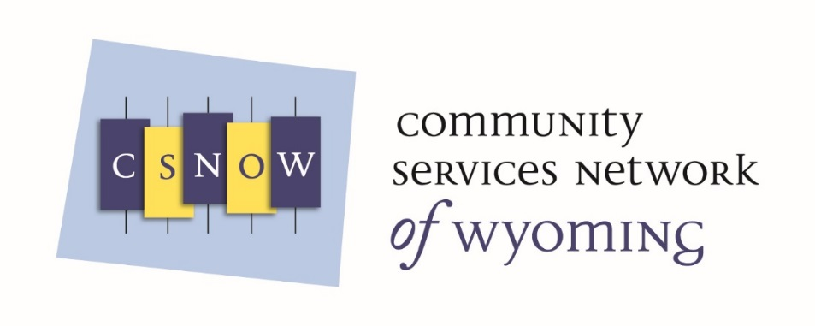
CSNOW Update Meeting Agenda 10-18-2017
4:30-5:30
Mission: CSNOW will provide advocacy, training, and technical assistance for CSBG Grantees, as they partner with other agencies to provide services that support self-sufficiency for people living in poverty.
- The formation of Community Services Network of Wyoming
- Status and description of Contracts
- Discussion: How can CSNOW Help you?
- CSNOW Board: Who are they and What do they do?
- How to become a Member?

