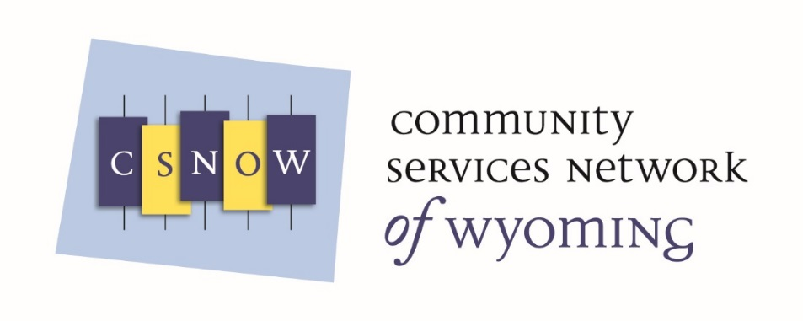
Mission: CSNOW will provide advocacy, training, and technical assistance for CSBG Grantees, as they partner with other agencies to provide services that support self-sufficiency for people living in poverty.
On September 25th, 2017 CSNOW received an exemption letter from the IRS officially making CSNOW a 501(c)(3) organization. CSNOW applied for and was awarded the RPIC grant. Align will serve as the fiscal agent for this grant. RPIC Grants are awarded to state associations for training and technical assistance. The State of Wyoming has contracted with Align to provide technical assistance and training for Community Action Agencies and Tripartite Boards, and to support CSNOW. This funding is out of the state’s discretionary funding pool. Goals and deliverables for these grants are outlined below.
RPIC grant (October 1, 2017 – September 30, 2018):
- Goal: CSNOW will improve the Wyoming CSBG Network information dissemination
- Establish statewide learning communities
- Increase participation in Region 8 List-serve
- Disseminate information from National & Regional Partners
- Goal: CSNOW will increase access to ROMA training and technical assistance resources in Wyoming
- 1 CSNOW Representative becomes ROMA certified
- Conduct 4 introduction to ROMA trainings statewide
- Goal: CSNOW will improve Organizational Standards compliance and performance in Wyoming
- Training on the organizational standards
- Goal: CSNOW will improve tripartite board governance, engagement and empowerment in Wyoming
- 4 in person Board Trainings
- Provide a Board Handbook utilizing regional template
- Goal: CSNOW will develop a 3 year Strategic Plan
- CSNOW Board & CSBG Grantees work together to develop a strategic plan for CSNOW
- Goal: CSNOW will develop relationships with poverty focused agencies for future advocacy efforts.
- Support the effort of the national partners
- Build recognition for CSNOW in Wyoming
State grant deliverables (October 1, 20117 – September 30, 2017):
- Provide 3 ROMA trainings
- Provide 5 in-person Board trainings
- Provide 2 Webinars on the IS Survey
- Provide 2 Webinars on the NPIs
- Provide technical assistance on the organizational standards
- Provide support and technical assistance to the CSNOW Board of Directors

